Raise3D Hyper Speed PLA Technical Data Sheet
Hyper Speed PLA Filament is one of the specially developed high-speed filament line for FFF printing. During high-speed printing, the filament is rapidly fed into the heat block, and the polymer has very little time to melt itself from solid to a molten state, which can cause nozzle clogging and poor bonding quality between layers.
With optimized molecular weight and tunned flowability, Raise3D Hyper Speed PLA are able to achieve faster melting in the hot end and much prompter cooling after the material is extruded. As a result, the surface quality of parts printed by Hyper Speed filaments is smooth and most of the sharp details are kept. Most importantly, thanks to optimized molecular weight, Hyper Speed PLA shows excellent interlayer bonding quality and Z-direction strength. Therefore, Hyper speed PLA can be used for concept models and figures, prototyping, etc.

Physical Properties

Property | Testing Method | Typical Value
Density (g/cm³) | ISO 1183, GB/T 1033 | 1.21
Heat Distortion Temperature (°C) | ISO 75 0.45MPa | 53
Melt Flow Index (g/10 min) | 190 °C, 2.16 kg | 4.5
Water absorption (%) | ISO 62: Method 1 | 0.4
Odor | / | Almost odorless
Solubility | / | Insoluble in water

Mechanical Properties

Property | Testing Method | Typical Value
Young’s modulus (X-Y) | ISO 527, GB/T 1040 | 2600 ± 215 MPa
Young’s modulus (Z) | ISO 527, GB/T 1040 | 2475 ± 234 MPa
Tensile strength (X-Y) | ISO 527, GB/T 1040 | 48 ± 7 MPa
Tensile strength (Z) | ISO 527, GB/T 1040 | 39 ± 4 MPa
Elongation at break (X-Y) | ISO 527, GB/T 1040 | 9.6 ± 0.8 %
Elongation at break (Z) | ISO 527, GB/T 1040 | 3.8 ± 1.4 %
Bending modulus | ISO 178, GB/T 9341 | 2700 ± 154 MPa
Bending strength | ISO 178, GB/T 9341 | 81 ± 2 MPa
Impact strength | ISO 179, GB/T 1843 | 4.3 ± 1.3 KJ/m²
Note:
All testing specimens were printed under the following conditions:
Nozzle diameter=0.4mm, nozzle temperature = 220 °C, printing speed = 200 mm/s, build plate temperature = 60 °C, infill = 100%
All specimens were conditioned at room temperature for 24h prior to testing.

Testing Geometries

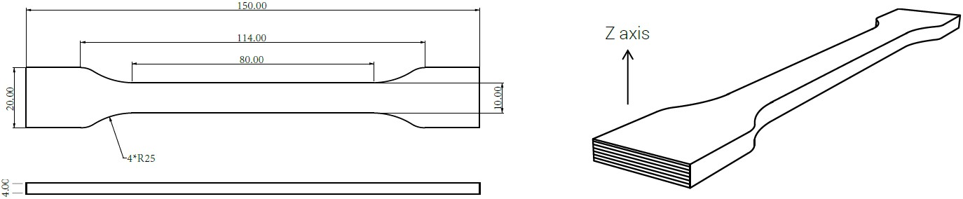

Fig 1. Tensile testing specimen

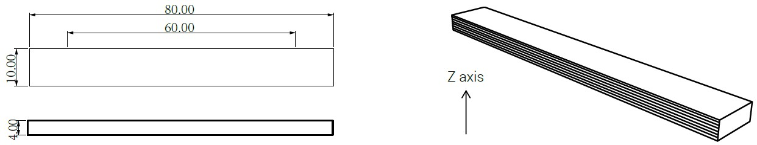

Fig 2. Flexural testing specimen

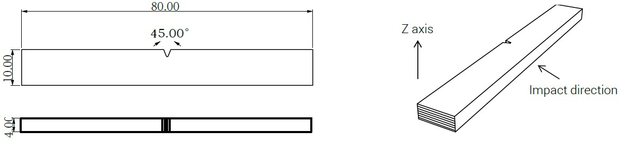
Fig 3. Impact testing specimen

Disclaimer

The typical values presented in this data sheet are intended for reference and comparison purposes only. They should not be used for design specifications or quality control purposes. Actual values may vary significantly with printing conditions. Enduse performance of printed parts depends not only on materials, but also on part design, environmental conditions, printing conditions, etc. Product specifications are subject to change without notice.

Each user is responsible for determining the safety, lawfulness, technical suitability, and disposal/recycling practices of Raise3D materials for the intended application. Raise3D makes no warranty of any kind, unless announced separately, to the fitness for any particular use or application. Raise3D shall not be made liable for any damage, injury or loss induced from the use of Raise3D materials in any particular application.

